Lucas Swanson
5/05/2025
Software Engineering Methods
Homework 6 (CodeScene)
- Creating an account:
  - 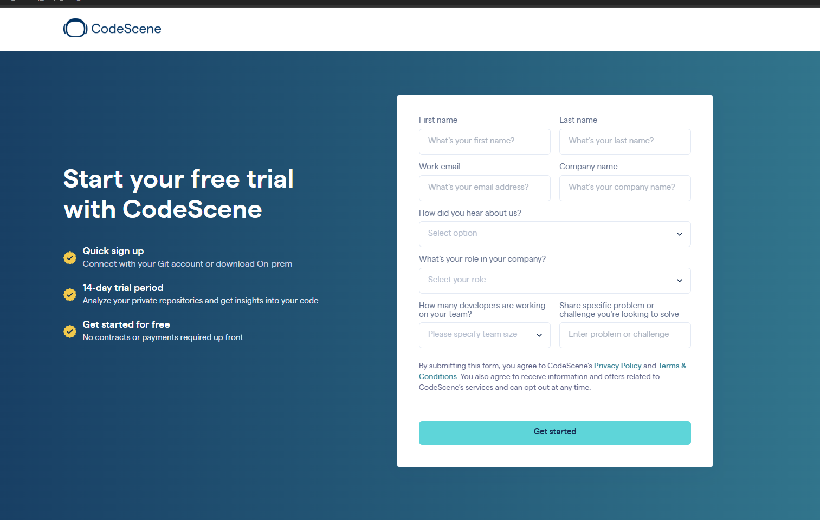
  - First step is to start a free trial by signing up on the CodeScene website: Start your free trial | CodeScene
Configuring the AI
- Next you need to select a cloud base as we hold our code in github:
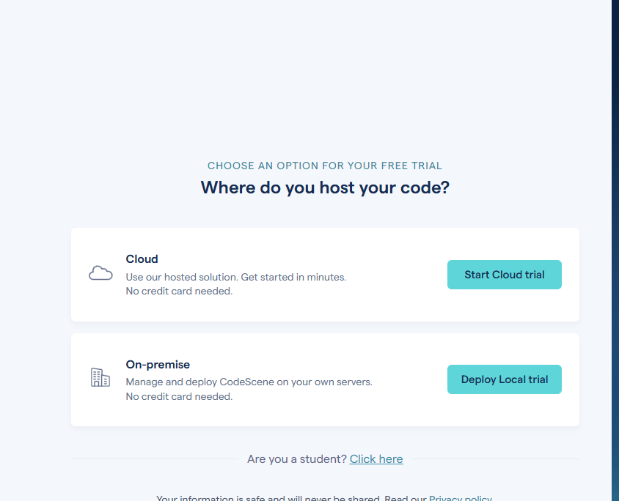
- You will want to grant them access to your github account:
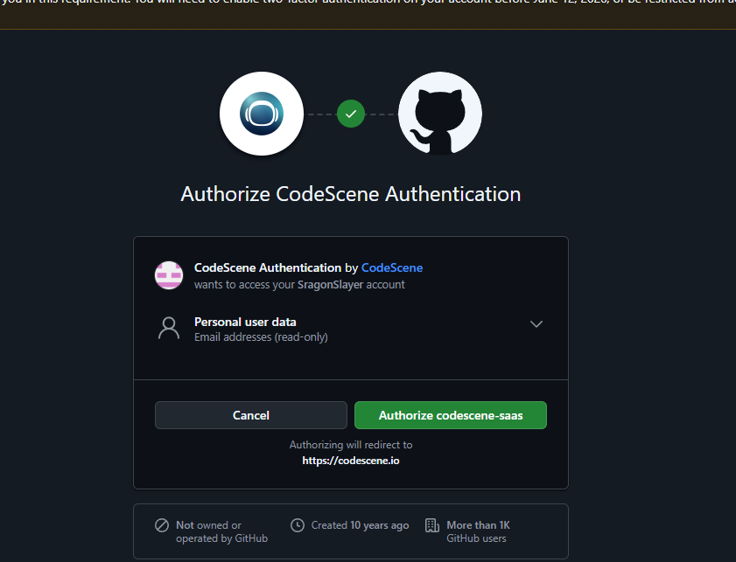
- Then select which repository you want analyzed:
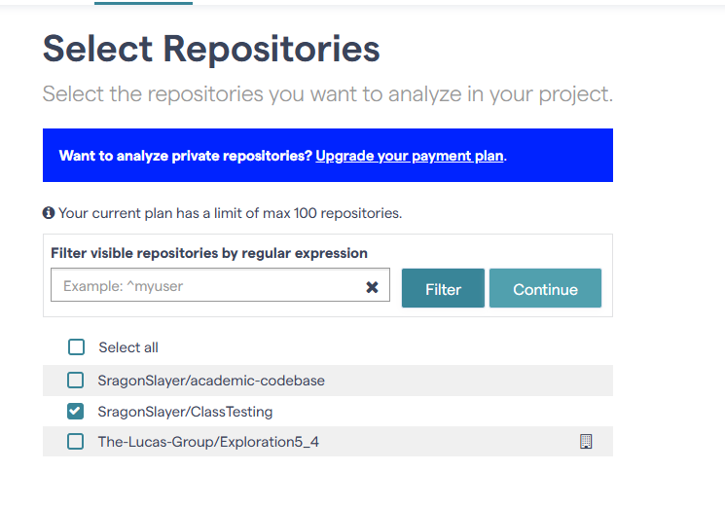
- And also configure the tool to integrate with Pull Requests:
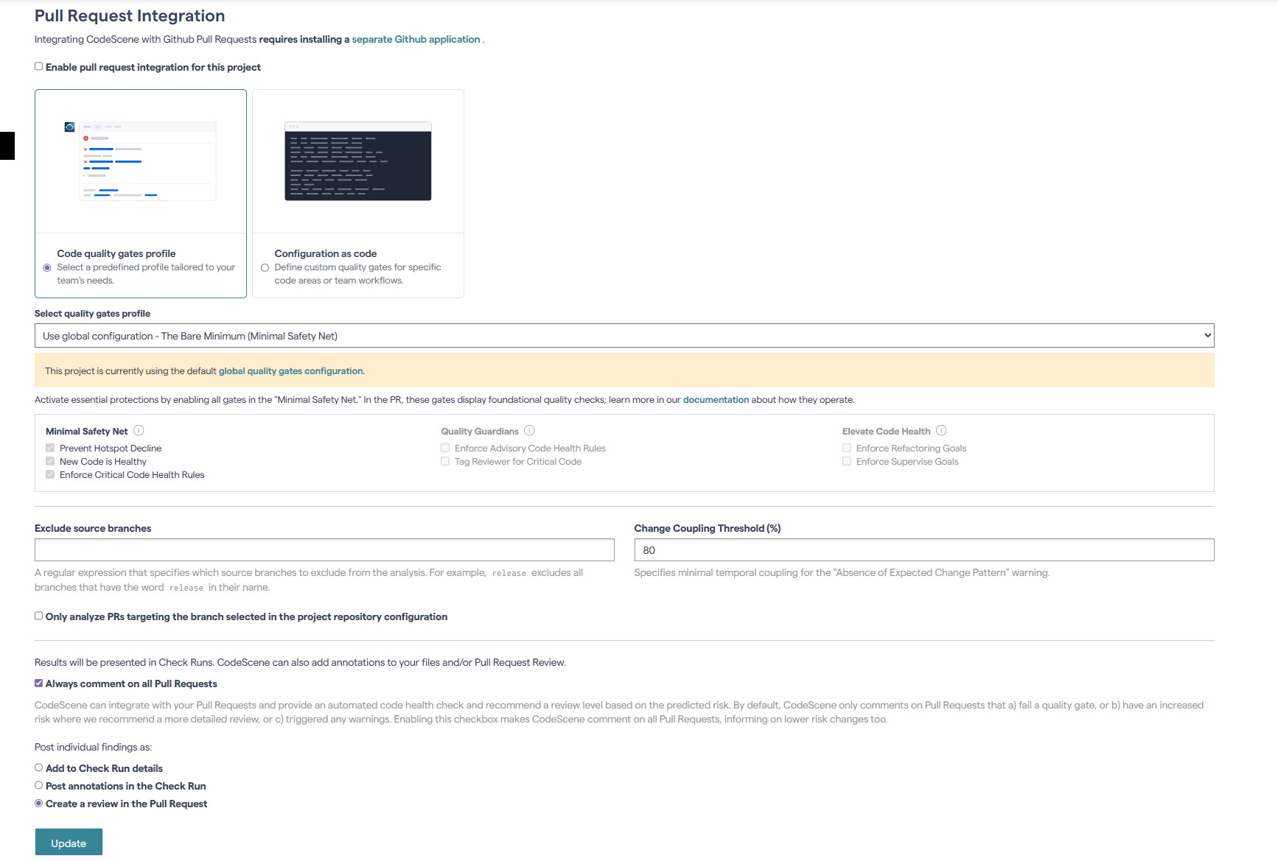
- Once the tool is configured, it will automatically review code based on the criteria defined:
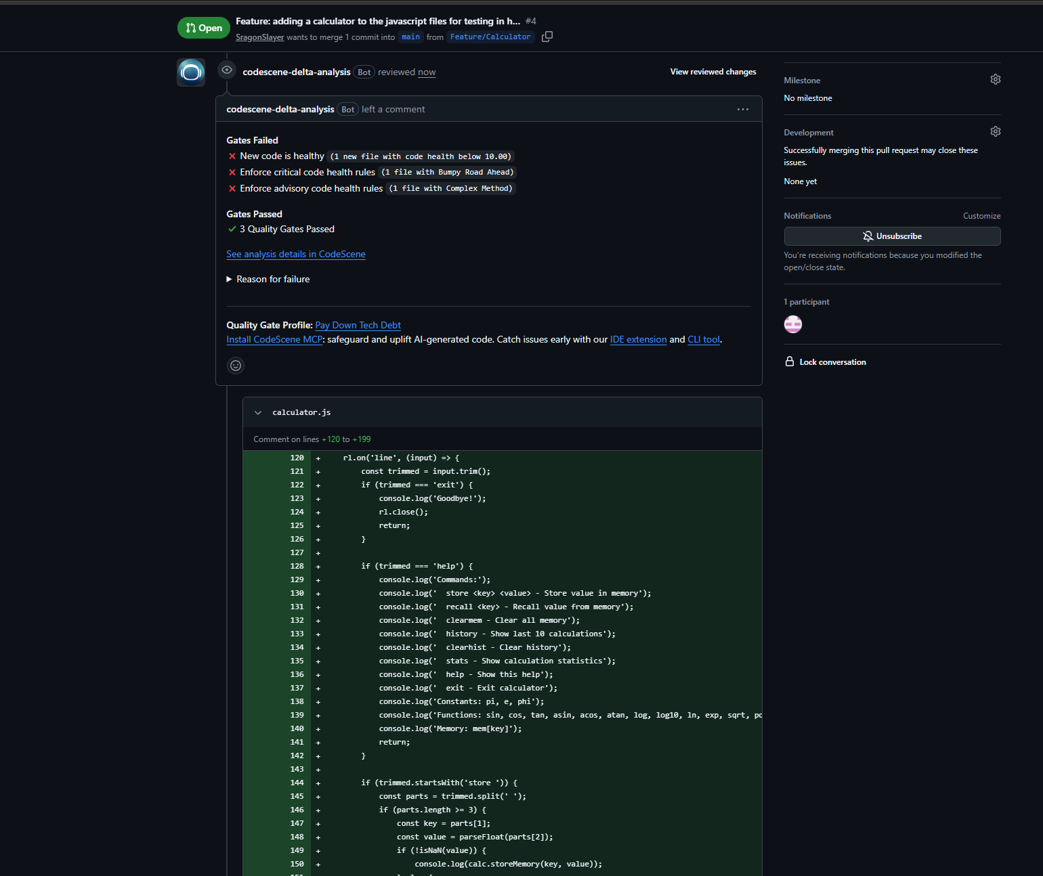
Analysis:
This tool is helpful, but it lacks a lot of qualities needed when updating code. This would be good for low-level linting, catching typos, and some other static code analysis. But it lacks contextual understanding that another developer would normally catch. For example in this PR I have made, it only caught issues with the cyclomatic complexity being above 10, and nothing else. I am sure this could be expanded with further configuration settings, but I don’t think it could replace a humans review.

